EXPERIMENT 16 : FEED FORWARD NEURAL NETWORK
QUESTION
Write a Python program to implement a Feed Forward Neural Network using the sigmoid activation function.
AIM
To write and execute a Python program to implement a Feed Forward Neural Network and obtain the final output.
PROCEDURE
- Start the program.
- Import the math module.
- Initialize the input values, weights, and bias.
- Calculate the weighted sum of the input values.
- Apply the sigmoid activation function to calculate the hidden layer output.
- Pass the hidden layer output to the output layer.
- Calculate the final output using the sigmoid activation function.
- Display the hidden layer output and final output.
- Stop the program.
PROGRAM
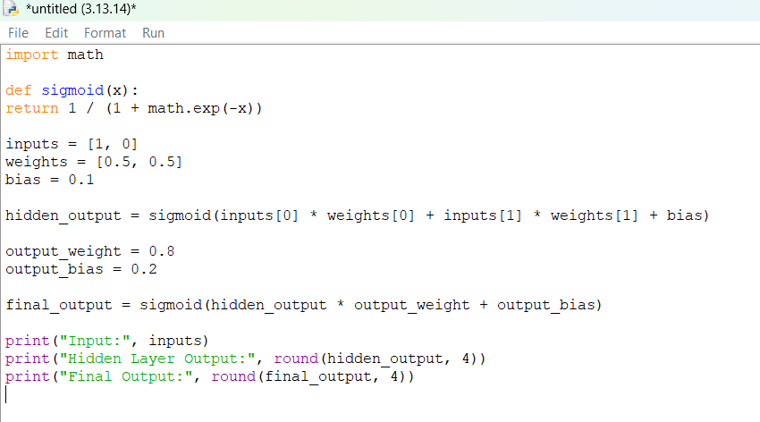

OUTPUT
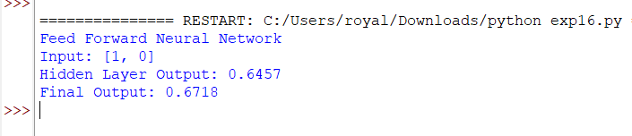

RESULT
Thus, the Python program to implement a Feed Forward Neural Network using the sigmoid activation function was successfully executed, and the final output was obtained.

